Name: ___________________________________________ Date: ____________________
4.MD.1

Hannah’s class was conducting a science experiment using toy cars. They would roll a car down a ramp and measure how far the car traveled. When Hannah filled out her recording sheet about her car, she wrote the following:
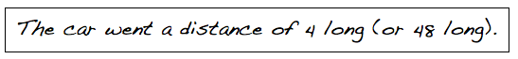

Hannah’s answer did not include the units she used. She
UNIT BANK
millimeters
inches
yards
meters
feet
centimeters

used two of the units shown in the UNIT BANK. Fill in the
blanks to show the units that she used when measuring the
distance her car traveled.
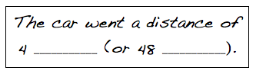

Hannah’s classmate Caleb conducted the same car experiment, and he also forgot to write the units with his data. Hannah filled in the units that she thought he used.
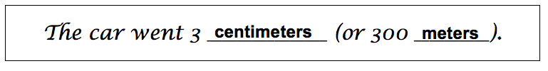

Explain why the units Hannah chose make the statement unreasonable.

_________________________________________________________________________________________________

_________________________________________________________________________________________________

_________________________________________________________________________________________________

_________________________________________________________________________________________________
Teacher notes:

• Students may need to do calculations on paper, either to solve or to check their work. Encourage the students to use any space on the paper to show their thinking. Some students may require more space than the paper provides or may need the lines of notebook paper to structure their work. You may choose to give those students, or all students, extra paper on which they can do their calculations.
• A student should fill in the first pair of blanks with the words “feet” and “inches”, respectively. The student’s explanation for the final part of the task should indicate an understanding that centimeters are smaller than meters and that if a given length is measured in both centimeters and meters, that the number used for centimeters will be larger than the number used for meters. The level of specifics in the answers can help distinguish “substantial” from “full” accomplishment.
• As indicated in the rubric, students may make minor errors that do not relate to the target concept (i.e., not labeling numbers), but if the work shows a complete understanding of the relationship between units, they can still be rated as showing “full accomplishment”.

Not yet: Student shows evidence of misunderstanding, incorrect concept or procedure. |  | Got It: Student essentially understands the target concept.
0 Unsatisfactory:  Little Accomplishment  The task is attempted and some mathematical effort is made. There may be fragments of accomplishment but little or no success. Further teaching is required. | 1 Marginal:  Partial Accomplishment  Part of the task is accomplished, but there is lack of evidence of understanding or evidence of not understanding. Further teaching is required. | 2 Proficient:  Substantial Accomplishment  Student could work to full accomplishment with minimal feedback from teacher. Errors are minor. Teacher is confident that understanding is adequate to accomplish the objective with minimal assistance. | 3 Excellent:  Full Accomplishment  Strategy and execution meet the content, process, and qualitative demands of the task or concept. Student can communicate ideas. May have minor errors that do not impact the mathematics.
Adapted from Van de Walle, J. (2004) Elementary and Middle School Mathematics: Teaching Developmentally. Boston: Pearson Education, 65

