Name: ________________________________________________________ Date: ____________________
4.NBT.2

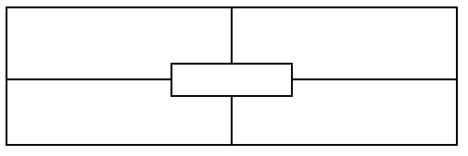
1,000 less than this number is...
This number in expanded form is…

442,099

The place value of the underlined digit…
The value of the underlined digit…

Name: ________________________________________________________ Date: ____________________
4.NBT.2

1,000 less than this number is...
This number in expanded form is…

442,099

The place value of the underlined digit…
The value of the underlined digit…

Teacher notes:

Not yet: Student shows evidence of misunderstanding, incorrect concept or procedure |  | Got It: Student essentially understands the target concept.
0 Unsatisfactory:  Little Accomplishment  The task is attempted and some mathematical effort is made. There may be fragments of accomplishment but little or no success. Further teaching is required. | 1 Marginal:  Partial Accomplishment  Part of the task is accomplished, but there is lack of evidence of understanding or evidence of not understanding. Further teaching is required. | 2 Proficient:  Substantial Accomplishment  Student could work to full accomplishment with minimal feedback from teacher. Errors are minor. Teacher is confident that understanding is adequate to accomplish the objective with minimal assistance. | 3 Excellent:  Full Accomplishment  Strategy and execution meet the content, process, and qualitative demands of the task or concept. Student can communicate ideas. May have minor errors.

Adapted from Van de Walle, J. (2004) Elementary and Middle School Mathematics: Teaching Developmentally. Boston: Pearson Education, 65

