Name: ________________________________________________________ Date: ____________________

4.NBT.2

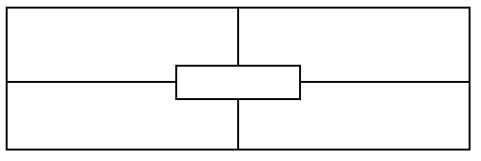

10,000 more than this number is...

This number in expanded form is…

**1,709**

The place value of the underlined digit…

The value of the underlined digit…

Name: ________________________________________________________ Date: ____________________

4.NBT.2



10,000 more than this number is...

This number in expanded form is…

**1,709**

The place value of the underlined digit…

The value of the underlined digit…

|  |  |  |  |  |  |  |  |  |
| --- | --- | --- | --- | --- | --- | --- | --- | --- |
| Teacher notes:   |  |  |  |  | | --- | --- | --- | --- | | **Not yet:** Student shows evidence of misunderstanding, incorrect concept or procedure | | **Got It:** Student essentially understands the target concept. | | | **0 Unsatisfactory:**  **Little Accomplishment**  The task is attempted and some mathematical effort is made. There may be fragments of accomplishment but little or no success. Further teaching is required. | **1 Marginal:**  **Partial Accomplishment**  Part of the task is accomplished, but there is lack of evidence of understanding or evidence of not understanding. Further teaching is required. | **2 Proficient:**  **Substantial Accomplishment**  Student could work to full accomplishment with minimal feedback from teacher. Errors are minor. Teacher is confident that understanding is adequate to accomplish the objective with minimal assistance. | **3 Excellent:**  **Full Accomplishment**  Strategy and execution meet the content, process, and qualitative demands of the task or concept. Student can communicate ideas. May have minor errors. | |
| Adapted from Van de Walle, J. (2004) Elementary and Middle School Mathematics: Teaching Developmentally. Boston: Pearson Education, 65 |