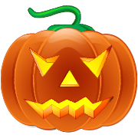
Mrs. Martinez’s class is making pumpkin shaped cookies for Halloween. The Chart below shows how many cups of sugar she will need to make different numbers of cookies. Use the pattern to figure out how many cups of sugar she will need to make 64 cookies.
Cups of Sugar | Number of Cookies
2 | 16
4 | 32
6 | 48
 | 64

What is the rule?______________________________________

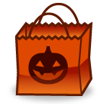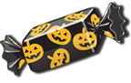
Mrs. Martinez’s is making all of her students goody bags with candy for Halloween. She uses the same number of candy for each bag. Use the Chart below to determine the number of candy she needs to use to make 25 bags.
Goody Bags | Candy
5 | 75
10 | 150
15 | 225
25

What is the rule?______________________________________

A set of numbers was created with the rule “Start with 5, Add 4”. What would be the first 6 numbers in this pattern?

What is the rule to describe the number patterns below?

3,9,27, 81

What is the rule for the table below?_________________________

Input | Output
0 | 0
4 | 24
5 | 30
6 | 36

The rule for the table below is “Start with 2, Multiply by 4”. Fill in the table.

Input | Output
2
4
6
8

